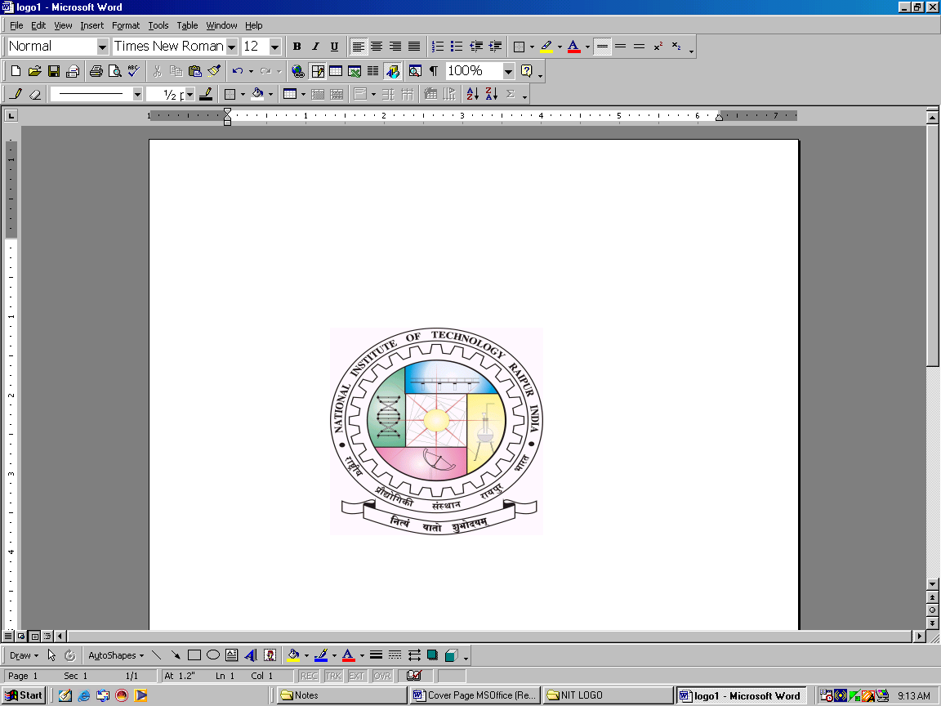**jk"Vªh; izkS|ksfxdh laLFkku jk;iqj**

**NATIONAL INSTITUTE OF TECHNOLOGY RAIPUR**

**(An Institute of National Importance)**

**G.E. Road, Raipur - 492010 (C.G)**

**Email:** [chiefwarden.boys@nitrr.ac.in](mailto:chiefwarden.boys@nitrr.ac.in), **Website:** [**www.nitrr.ac.in**](http://www.nitrr.ac.in)

No./NITRR/CW (B)/2024-25/…………… Date : 15./08/2024

**NOTICE HOSTEL ADMISSION 2024-25  
(BOYS HOSTEL)**

1. The list for boys’ hostels admission in Hostel – Mainpat, Chitrakot, Malhar and Kotumsar (for First year students only) is already declared on 16.08.2024. The hostel fee including mess advance for session 2024-25 is to be deposited as per following detail.

|  |  |  |  |
| --- | --- | --- | --- |
| **Part** | **Hostel Fee detail** | **For the Students admitted in academic year 2024-25** | **Mode of Payment** |
| I | Mess Advance I +  Caution Money +  Hostel Management & Maintenance Fee+ Digital Infrastructure Maintenance Charges | **25,500.00 only** | **QR Code (Attached in next page) State Bank I-Collect**  **Boys Hostel Account NIT Raipur**  Account No. **63028115707** |
| II | Room Rent + Water & Electricity Charges | **11,515.00 only** | **State Bank I-Collect**  **Director NIT Raipur**  Account No. **38027633250** |
| III | Mess Advance II  (To Be Paid at the beginning of Spring Semester | **17,500.00 only** | **QR Code (Attached in next page) State Bank I-Collect**  **Boys Hostel Account NIT Raipur**  Account No. **63028115707** |
|  | **Total Fee** | **54515.00** |  |

1. **The last date for deposition of the fees is 23/08/2024. (Friday)** **If the student fails to deposit Part I & II of the hostel fee till the above date, his admission will be treated as cancelled.**
2. If it is found that the student has provided wrong information at any stage of the admission process, his admission will be cancelled. In this case, only mess advance and caution money will be refunded.
3. The students will have to produce the proof of payment of institute and hostel fee to the hostel administration while taking the admission.
4. Part III of the hostel fee is to be deposited in spring semester. The date for deposition of Part III of the hostel fees will be notified later.

Chief Warden Boys’

National Institute of Technology,

Raipur (C.G)